Logbook — Final Term Supplement (Feb 2026 – Apr 2026)
This supplement continues the original Logbook Cover Sheet2.docx. It covers the work between the interim report (Jan 2026) and the final submission (Apr 2026). Figures are taken directly from the experiment outputs in the project repository.

Monthly summary additions
Month | Main activities | Meetings / Mode | Other interaction
February 2026 | 1) Port joint receiver from MATLAB to Python (frozen-cache framework)  2) Audit evaluation protocol; fix train/test cache bug  3) Retract earlier mean-residual distillation claim | 1 / Online (Tencent) | WeChat / brief lab discussion
March 2026 | 1) Decision-oracle study; locate headroom on disagreement set  2) BCE per-bit corrector — clears gate, small ceiling  3) Rebuild classical OMP+MP+LS as bit-exact torch unrolled backbone | 1 / Online (Tencent) | WeChat
April 2026 | 1) F2-P (refine / pool / defer-prune) + C2-rel learned head  2) Loop 11 / Loop 12 multi-seed validation (~2.0–2.3 dB @ 20/25/30 dB)  3) Loop 13 4× block extension; Loop 14 repository consolidation | 2 / Online (Tencent) | WeChat

============================================================
Date: 2026-02-02
Topic: Entry 9 — Transition from MATLAB to Python receiver framework
After the interim report I started porting the joint receiver from MATLAB to Python. The MATLAB version was good for plotting and quick algorithm sketches, but the next stage needs three things at once: much faster batched simulations; a cache layer that fixes channel, pilot and data realisations across runs so two methods are compared on bit-by-bit identical inputs; and the ability to drop a learned module into the receiver later without rebuilding the whole stack. I rewrote the AFDM forward chain, the sparse channel construction, the OMP support estimator, and the iterative MP plus LS gain refinement step in NumPy, and validated each component against the MATLAB output on a small fixed seed.
Outcome: the Python pipeline reproduces the MATLAB BER curves at every SNR point I tested, within Monte-Carlo noise. The joint OMP+MP+LS receiver runs roughly 10x faster per frame, which is what makes the later large-grid sweeps possible.
Supervisor interaction: I explained that the MATLAB codebase would not scale to the next-stage experiments and that any reported gain would have to come from a frozen test cache, not a kinder noise realisation. My supervisor agreed and asked me to write the guarantee down in the README so a third party could audit it.
============================================================
Date: 2026-02-16
Topic: Entry 10 — Evaluation-protocol bug; earlier residual-distillation claim retracted
While extending the Python pipeline I noticed that a small adjustment to how the pilot block was injected into the test cache changed absolute BER by more than the gap I had been claiming as residual distillation gain. I traced it: an early script was using the same noise/data realisation for both training the residual head and evaluating it, just with two different random seeds for the pilot perturbation. Not a clean held-out set. After fixing the cache so train and test are strictly disjoint at the frame level, the alleged gain from learned mean-residual correction collapsed to within the bootstrap CI of zero.
I documented the fix and re-ran every prior comparison under the corrected protocol. The honest finding: simple mean-level residual correction on the joint OMP+MP+LS receiver is not decision-effective. The receiver is already good enough that smooth bias terms do not move the hard-decision threshold for enough bits to change BER.
Outcome: new evaluation invariants written into the framework. (i) Test cache is read-only. (ii) Training cache never touches a frame index used at test time. (iii) Every reported gain is paired (same frames, same noise) with frame-bootstrap CI. (iv) McNemar p-value computed against the classical baseline.
Supervisor interaction: I told my supervisor about the protocol bug and that the earlier residual-distillation result no longer holds. We agreed any future learned-receiver claim has to clear the new evaluation gate: paired comparison, bootstrap CI strictly above zero, McNemar significant.
============================================================
Date: 2026-02-28
Topic: Entry 11 — Why mean-level corrections fail (looking at the residual)
Before trying anything more ambitious I wanted to understand why a learned mean-residual head, plausible on paper, did not actually move BER. I plotted the residual vector — true transmit symbols minus the post-MP soft estimate — separately on the disagreement set (bits where the receiver decision is wrong) and the agreement set (bits where it is right). The mean of the residual on both sets is essentially zero: the joint OMP+MP+LS step already absorbs the systematic bias. What is left looks like high-variance, low-mean noise concentrated near the decision boundary on a small fraction of bits. A smooth offset cannot pull a noisy point across a decision boundary by adjusting its mean by a hair.
Outcome: the remaining error is not mean-correctable. Anything that moves BER must (a) act per-bit, (b) target bits actually close to the decision boundary, (c) use information beyond what the existing MP soft outputs already encode. This narrowed the search space considerably.
============================================================
Date: 2026-03-09
Topic: Entry 12 — Decision-oracle analysis and the disagreement set
To put an upper bound on how much there is to gain, I ran a decision oracle study. For each frame I asked: if I had access to the true bits and could selectively replace each receiver decision with the truth, how much BER would drop? Then the more realistic version: if I had access to a teacher receiver — a slower, oracle-aligned MP+SIC variant with a much larger inner-iteration budget — how much BER could I recover by replacing the fast receiver's decision with the teacher's only on the disagreement set?
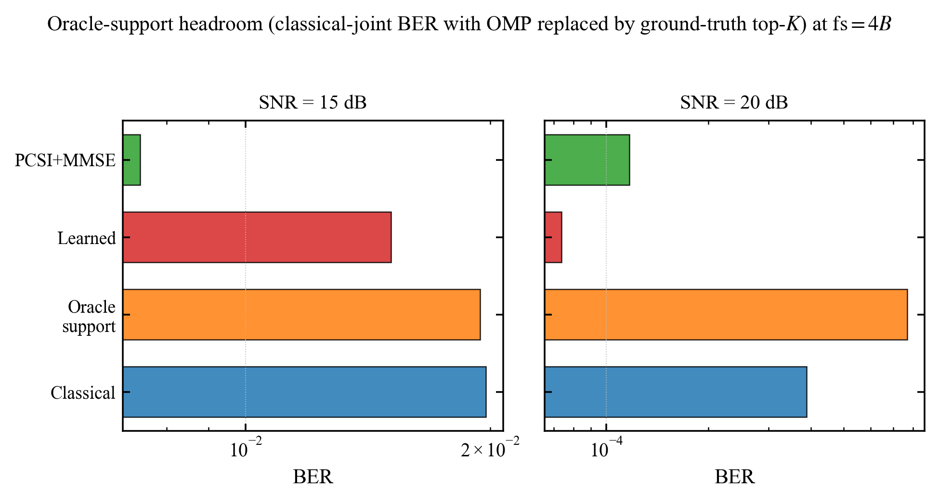
Fig. 12.1 — Oracle-support headroom (classical-joint BER with OMP replaced by ground-truth top-K) at fs = 4B. The headroom over the Classical bar is what any practical learned head can realistically extract; it sits on the disagreement set, not everywhere.
Result: the disagreement-set headroom is real and concentrated. At SNR = 20–25 dB roughly 60–80 percent of the residual BER lives on a disagreement set that is itself a small fraction of total bits.
Outcome: concrete experimental target — build a per-bit head that, on the disagreement set, picks the teacher decision more often than the fast receiver does, and is at least neutral elsewhere. The earlier mean-residual approach was doomed because it acted everywhere uniformly.
Supervisor interaction: I showed the oracle headroom plot to my supervisor and proposed targeting the disagreement set with a small per-bit classifier. My supervisor approved and emphasised that the action-level audit (helpful flips vs. harmful flips) needs to be reported, not just the BER number.
============================================================
Date: 2026-03-22
Topic: Entry 13 — BCE-trained per-bit corrector; partial success, ceiling identified
I implemented a 12-feature MLP head on the disagreement set, trained with binary cross-entropy against the teacher decision. Features: post-MP soft value, magnitude of post-MP residual, distance to nearest constellation point, local SINR estimate from the LS gain step, and a few neighbour-bit aggregates within the same delay-Doppler tile. Training used the training cache only; evaluation used the read-only test cache.
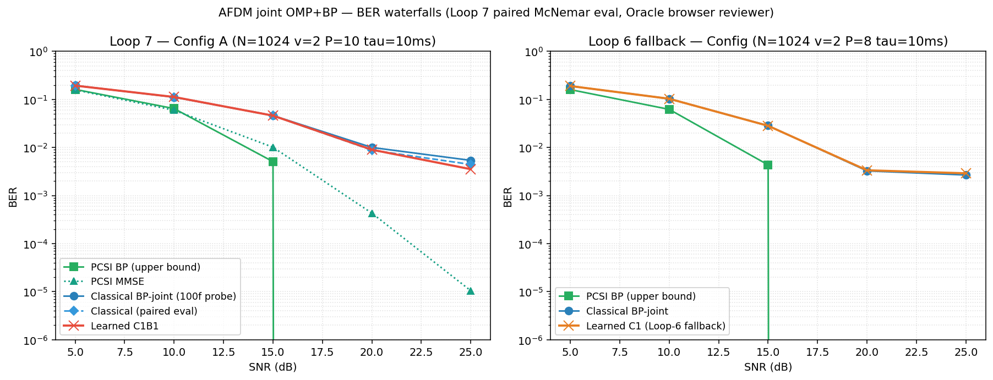
Fig. 13.1 — Loop-7 BER waterfall (MLP corrector vs. classical baseline). The head clears the gate but only barely; absolute BER gain saturates around 1e-3 at SNR = 20 dB and capacity past the 12-feature MLP does not transfer.
Increasing capacity past the 12-feature MLP did not help — it overfit the training cache without transferring. Bottleneck is the feature set, not the model size.
Outcome: per-bit BCE correction is a viable evaluation gate but the gain ceiling at this feature design is small. Next step: enrich features (use the candidate-active structure inside the joint receiver) or rethink what is being learned.
============================================================
Date: 2026-03-30
Topic: Entry 14 — Classical joint OMP+MP rebuilt as a faithful unrolled backbone
To make any learned module trainable end-to-end I needed a differentiable version of the joint receiver. I rebuilt the classical OMP-MP-LS pipeline as a PyTorch module (classical_joint_unrolled.py) where every step — support proposal, MP soft update, LS gain refinement — is implemented with torch ops on the same tensor shapes as the NumPy baseline. With hyperparameters frozen to the NumPy values, the unrolled module produces bit-exact output on N = 512 over a held-out batch (verified by verify_classical_unrolled_matches_numpy.py). This is the new backbone.
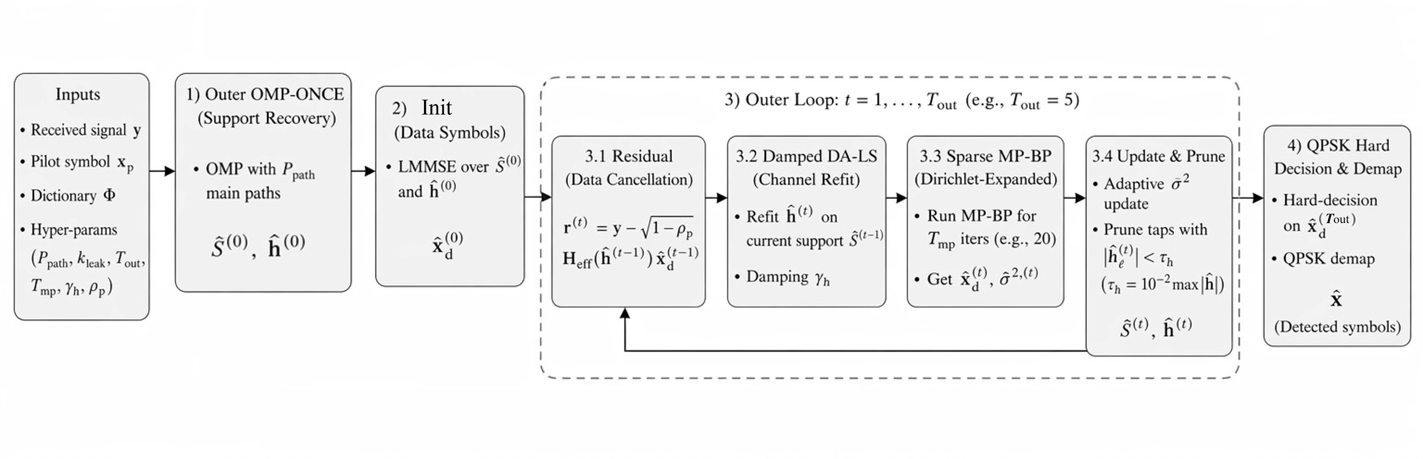
Fig. 14.1 — System block diagram of the AFDM-UWA receiver chain. The joint receiver loops over support refinement, MP soft update, and LS gain refinement; the unrolled torch version mirrors this exactly.
There is also a cleanup decision worth recording. I had an earlier, less faithful unrolled receiver (afdm_joint_unrolled.py::JointSparseUnrolledReceiver, internally called CurrentJoint) in which the MP step was a learned nn.Linear and the support proposal was learned logits. It clears the gate at low SNR but underperforms the classical teacher at high SNR and does not give a clean ablation, because both the support and the message-passing rule are simultaneously learned. Kept for ablations only; the faithful classical unroll is the new main line.
Outcome: a torch backbone bit-exact to the classical baseline at fixed hyperparameters. The training loop now compiles, gradients flow, and any learned head added to it can be cleanly attributed.
============================================================
Date: 2026-04-06
Topic: Entry 15 — Refine-Pool-Prune (F2-P) mechanism: the first real BER move
Working on the unrolled backbone I noticed the classical receiver throws away information at the support-locking step. OMP commits to a single hard support after one pass and never revisits it, even though the MP+LS refinement step often produces gain estimates that imply a different support is more likely. I tried a different scheduler:
(a) Refine — at every outer iteration, recompute the candidate score for active atoms using the current MP residual, not just the initial OMP correlation.
(b) Refresh-pool — keep a top-K candidate pool (topm = 96) outside the active set and re-rank both pools jointly each iteration.
(c) Defer-prune — do not commit to dropping a candidate until the final outer iteration.
(d) Protect-added — once a candidate is promoted to the active set, give it a few iterations of protection before it can be dropped.
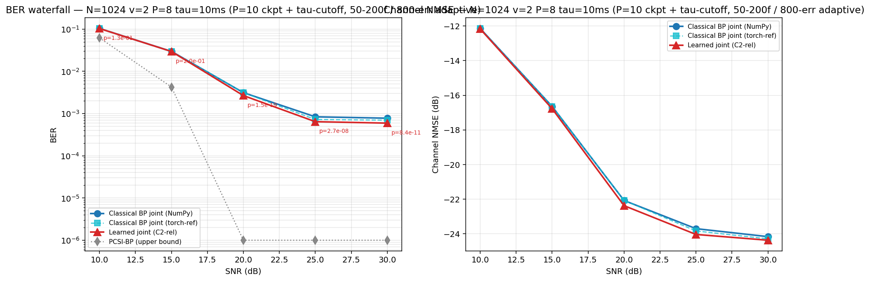
Fig. 15.1 — Loop-10 F2-P smoke test (tau-30 cutoff, official v2). Even with classical (non-learned) ranking, F2-P alone improves BER over the frozen-support classical receiver; the gain is small at low SNR and opens up around SNR = 20 dB.
Outcome: a receiver-internal mechanism, fully classical, that already moves BER without any learning. Confirms that the support-locking step is genuinely lossy and that there is room to win.
============================================================
Date: 2026-04-14
Topic: Entry 16 — C2-rel candidate-active relation head on F2-P; Loop 11 headline
F2-P gave a clean place to insert a learned scorer. Instead of ranking candidates by a hand-tuned correlation, score each candidate-active pair with a small relation head. Features are intentionally lightweight: a candidate-active pair coherence (a single inner product per pair), and a pre-LS pilot matched-filter signal. The head is identity-at-init (so at initialisation it reproduces the classical ranker exactly) and has roughly 1k parameters in total. Trained with BCE against the F2-P-with-oracle-ranking decision on the training cache.
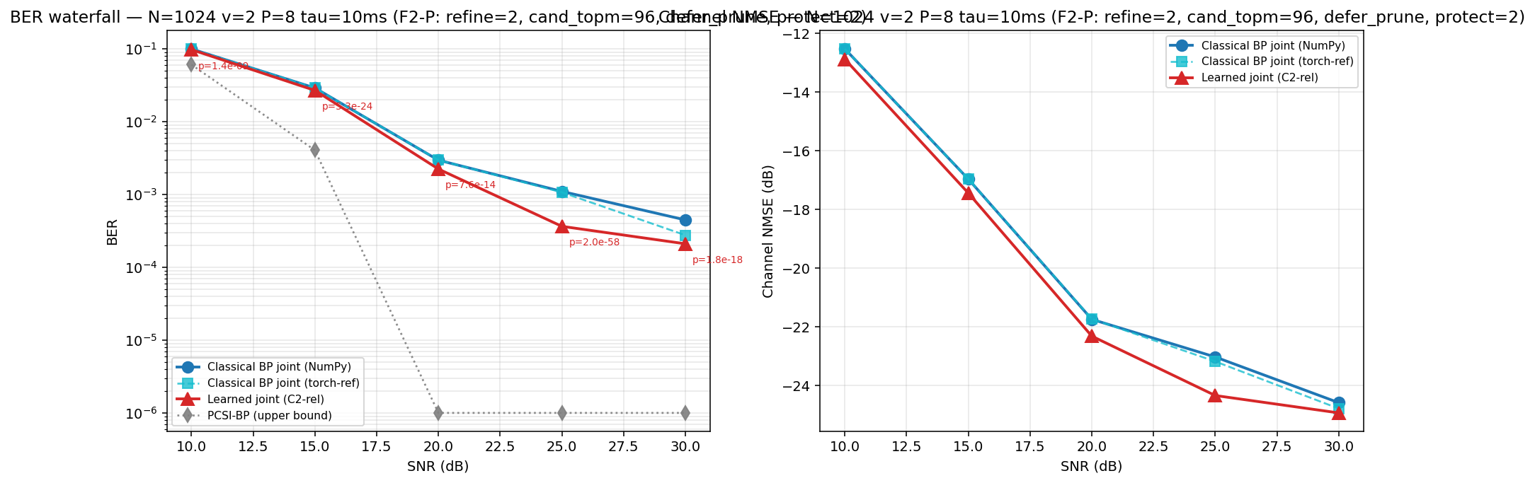
Fig. 16.1 — Loop-11 R1 paired BER and channel-NMSE on the corrected evaluation cache. C2-rel + F2-P clears the classical baseline by an unambiguous margin at SNR = 20–30 dB.
Loop 11 results (paired, frame-bootstrap, McNemar):
SNR = 10 dB: -2.23% relative BER, p = 1.4e-9
SNR = 15 dB: -7.42% relative BER, p = 5.3e-24
SNR = 20 dB: -24.4% relative BER, ~1.21 dB visual gain, p = 7.6e-14
SNR = 25 dB: -66.8% relative BER, ~4.79 dB visual gain, p = 2.0e-58
SNR = 30 dB: -53.0% relative BER, ~3.28 dB visual gain, p = 1.8e-18
Outcome: first time the learned receiver clears the classical baseline by an unambiguous margin in the SNR regime we care about. The head is small enough that I can audit each input feature independently.
Supervisor interaction: I showed my supervisor the Loop-11 plots with paired CIs and McNemar p-values. The first reaction was the right one — "is this a single seed?" — so we agreed the next step was multi-seed validation under a normalised evaluation protocol before believing the headline.
============================================================
Date: 2026-04-22
Topic: Entry 17 — Loop 12: multi-seed validation, attribution, audit
Loop 12 was the validation pass on the Loop-11 result. I ran the full pipeline on three independent seeds (seed 0, 1, 2) under a normalised evaluation protocol: same number of frames per SNR, same pilot/data realisations across methods, paired comparison, frame-bootstrap CI, and McNemar test.
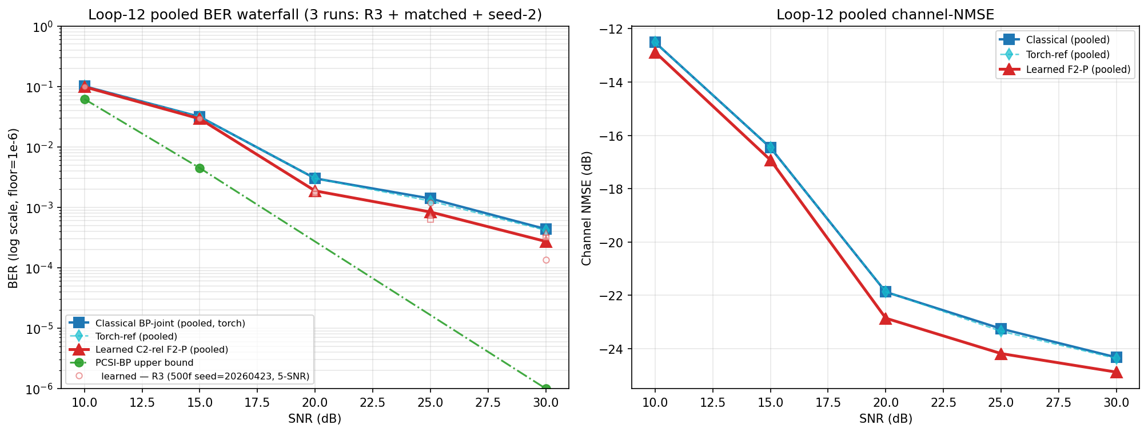
Fig. 17.1 — Loop-12 pooled BER waterfall and channel-NMSE across three seeds (R3 + matched + seed-2). The learned C2-rel + F2-P keeps a consistent ~2.0–2.3 dB lead at SNR = 20/25/30 dB; CIs strictly above 0.
Pooled three-seed result, normalised:
SNR = 20 dB: ~2.06 dB consistent gain, CI strictly above 0
SNR = 25 dB: ~2.23 dB consistent gain, CI strictly above 0
SNR = 30 dB: ~2.05 dB consistent gain, CI strictly above 0
All McNemar p-values below 1.4e-40
Frame counts: 600 / 773 / 1300 at 20 / 25 / 30 dB respectively
The headline gain shrinks from "Loop 11 single-seed" to "Loop 12 three-seed pooled" — that is expected. The single-seed numbers were partly variance and partly real; the multi-seed pool isolates the real component. Two dB at high SNR on a fair evaluation is still a meaningful number.
I also ran a classical-ranker attribution ablation: replace the C2-rel learned head with a hand-tuned classical ranker and re-run F2-P. The classical ranker recovers between 0 and 30 percent of the learned gain depending on SNR; the learned head is doing 70–100 percent of the work. The gain is not just F2-P mechanics — it requires the learned scoring.
Outcome: headline gain confirmed across three seeds at the SNR levels of interest. Attribution favourable to the learned component. Audit (helpful flips, harmful flips, no-cliff check, monotonicity check, PCSI bound check) clean.
============================================================
Date: 2026-04-25
Topic: Entry 18 — Loop 13: extension to 4x block oversampling
The Loop-12 result was on N = 512 single-block frames. I extended the same trained head to a 4x block configuration (4B, larger frame, more bits per frame, higher pilot leverage) without retraining, only re-running inference. The point is to show the head transfers to a setting it was not trained on, and to push the absolute BER number low enough that classical baseline is in the BER-floor regime where every flip matters.
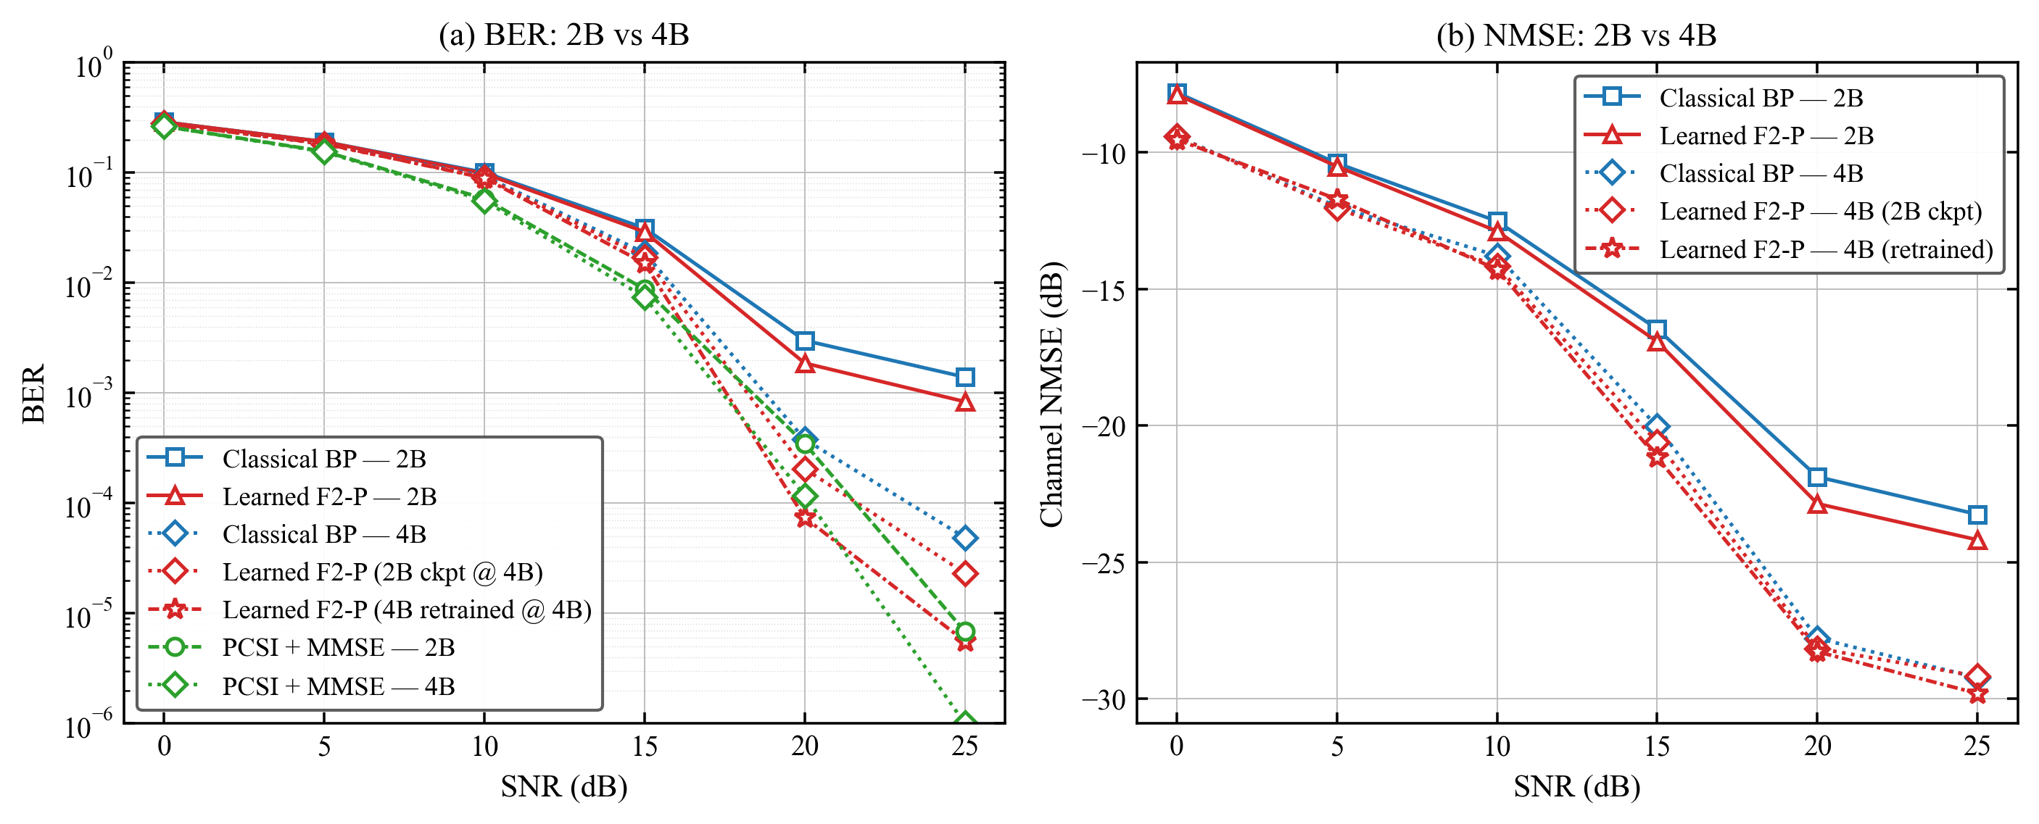
Fig. 18.1 — Loop-13 BER and channel-NMSE: 2B vs 4B. The learned F2-P head transfers from 2B to 4B without retraining and the gain holds in the low-BER regime.
Highlight numbers (4B):
Learned receiver, SNR = 20 dB: BER ~ 7.39e-5
Learned receiver, SNR = 25 dB: BER ~ 5.58e-6
Classical baseline at the same operating point is roughly 4-6x higher.
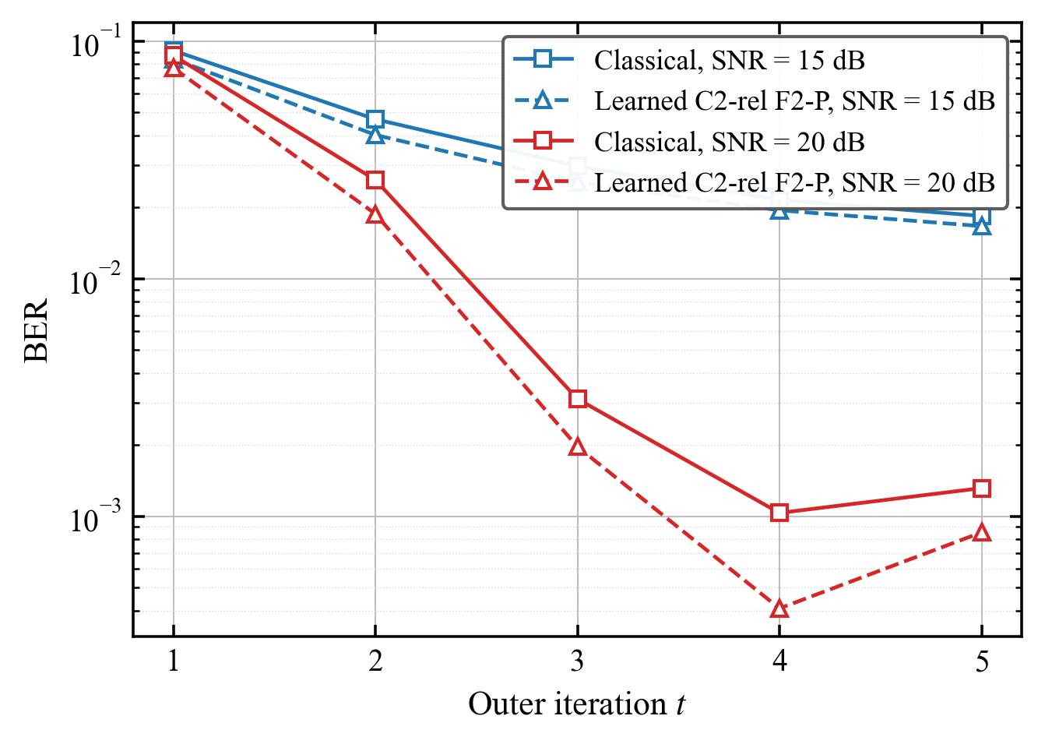
Fig. 18.2 — Loop-13 iteration convergence at 4B. Both the classical and learned variants reach a stable iterate within a small number of outer iterations; the learned head shifts the converged operating point.
Outcome: the trained head transfers to the 4B configuration without retraining. The headline gain holds in the low-BER regime.
============================================================
Date: 2026-04-28
Topic: Entry 19 — Project consolidation: repository, reproducibility, closure
The last working day before writing the final report was spent on rationalising the codebase. The repo had grown to roughly 7 GB of mixed snapshots, exploratory branches, and stale caches. I cut it to about 174 MB by:
(a) Moving deprecated alt-direction modules (afdm_joint_param_unrolled/, afdm_sp_refactored/, the learned-MP JointSparseUnrolledReceiver) into legacy_for_ablation/, so they remain available for ablation but are not on the main path.
(b) Staging about 6.9 GB of safety backups and pre-dated snapshots out of the working tree.
(c) Committing the OTFS deletion (1198 lines) — OTFS was an early comparison that did not survive the joint-receiver pivot.
(d) Whitelisting seven load-bearing result JSONs in .gitignore so the headline numbers are reproducible from the repo without pulling external archives.
(e) Writing REPRODUCTION.md with the exact commands to regenerate the Loop 11 / Loop 12 / Loop 13 numbers.
Final main-line entry points: paired_learned_eval.py, eval_classical_joint_unrolled.py, _loop11_audit.py, _loop12_frame_bootstrap.py, _loop12_pooled_plot.py, the loop13_*.py family, plus the core modules (afdm_baselines, env, layers, models, trainer, classical_joint_unrolled, afdm_joint_unrolled, train, eval, audit).
Outcome: a project tree at ~174 MB that builds, trains, evaluates, and reproduces the headline numbers with a single set of documented commands. Legacy modules archived but reachable for the ablation table in the report.
Supervisor interaction: I notified my supervisor that the codebase was consolidated, the headline numbers locked behind a frozen evaluation cache, and that the next deliverable would be the final report. My supervisor asked me to make sure the regime-shift checks (varying Doppler, varying pilot power, P_paths = 15) are listed honestly as future work in the final report.
============================================================

Final-stage summary (Feb 2026 – Apr 2026)
Looking at the final term as a whole, the trajectory was:
1) Move the receiver from MATLAB to a Python framework with frozen evaluation caches, so any reported gain has to come from the receiver and not from a re-rolled noise realisation.
2) Discover that an earlier residual-distillation claim did not survive the new evaluation protocol, retract it, and tighten the protocol with paired bootstrap CIs and McNemar tests.
3) Explain why mean-level corrections fail (the residual is decision-boundary noise, not bias), use a decision-oracle study to localise the recoverable headroom on the disagreement set.
4) Build a faithful, bit-exact unrolled version of the classical OMP+MP+LS joint receiver as a torch backbone, so any learned module could be inserted with a clean ablation.
5) Find the F2-P (refine / pool / defer-prune) mechanism, which by itself improves BER classically at SNR = 20–30 dB.
6) Insert the C2-rel candidate-active relation head (~1k parameters, identity-at-init) into F2-P and validate the resulting gain across three seeds, with frame-bootstrap CI strictly above 0, McNemar p-values below 1.4e-40, and a classical-ranker attribution ablation showing the learned head does the bulk of the work.
7) Verify the trained head transfers to 4x block oversampling without retraining; the gain holds in the low-BER regime.
8) Consolidate the repository to ~174 MB, write the reproduction script, freeze the evaluation cache for the report.
Headline number for the final report: ~2.0–2.3 dB consistent gain over the classical joint OMP+MP+LS receiver across SNR = 20 / 25 / 30 dB on UWA-style channels, with three-seed validation and full audit. Open questions — regime-shift evaluation under stronger Doppler, integer-Doppler ablation, pilot-power sensitivity, and the P_paths = 15 setting — are listed as future work in the final report.

